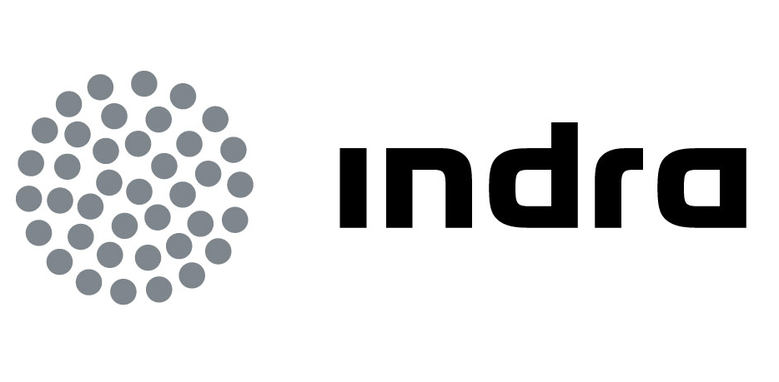 | Press release
INDRA AWARDED THE FAMILY-RESPONSIBLE COMPANY CERTIFICATE AGAIN AND GAINS “PROACTIVE” STATUS

• The efr certificate awarded by the +Familia Foundation acknowledges Indra’s commitment to conciliation, equality and diversity management and to continuous improvement in this aspect

• Special consideration was given to Indra’s involvement in the management of disabilities, an aspect the company incorporated into diversity, conciliation and gender equality

Indra, the premier IT company in Spain and a leading IT multinational in Europe was awarded once again the certificate of family-responsible company (EFR) by the + Familia Foundation. The company has taken a leap from the committed category to the proactive one, thanks to its global score. The certificate, obtained in 2008, acknowledges the company’s commitment to conciliation, equality, diversity management and to continuous improvement.
The +Familia foundation granted the certificate to Indra after an internal and an external audit. The later was carried out by AENOR and dealt with the policy of Human Resources in compliance with the EFR 1000-1 regulation. The +Familia Foundation took into account the policies and initiatives oriented to provide professional support to employees in terms of family conciliation, employment quality, flexibility, equality of opportunities and integration.
Special consideration was given to Indra’s initiatives in the areas of disability management, conciliation and gender diversity. The company implemented a programme, “Sumando capacidades” which comprises all the steps taken towards the integration of people with disabilities, such as scholarships for students with impairments, or the procedures to integrate professionals and a volunteering corporate programme specially oriented to this sector.
With the efr certificate Indra renovates its long-term commitment to conciliation and equality policies, ensuring a continuous improvement in this field since the certificate is valid for three years after which, a new audit is required for a renewal.
According to the +Familia Foundation, the erf certificate is a synonym of good employer, an excellent workplace, a balanced and flexible organisation who respects the private life of workers, that is, a family-responsible company”. The classification includes four categories: skeptical, committed, proactive and excellent.

The + Familia foundation is a private, non-denominational and non-profit entity. It does not depend on politics and tries to promote, defend and protect families, specifically those that depend on the foundation.
Commitment to diversity
As a global company with over 30,000 professionals from 40 different countries, gender and age, for Indra diversity management is a must, a sort of a propeller to innovation contributing to future sustainability and a key element to promote thorough social responsibility policies.
Indra’s policies cover areas like diversity management, conciliation measures and an Equality Plan. The company adhered this year to the Women’s Empowerment Principles, an initiative conceived by the United Nations Global Compact and the United Nations Development Fund for Women (UNIFEM) which started in 2010. With this step, Indra reaffirms its commitment to equality, in compliance with its Code of Ethics.
Indra’s Equality Plan consists of initiatives related to access to employment, selection and promotion, training, work-life balance, pay, specific measures to prevent sexual harassment/gender discrimination and communication.
Indra occupies the first position in the Ibex-35 in terms of amount of women on Boards. From 2005 on, Indra’s Board of Directors has observed this aspect carefully for a wider gender diversity within its corporate governance.
Leadership in sustainability
Indra’s commitment to sustainability reflects in its response to challenges and opportunities present in its target sectors: shareholders, staff, clients, suppliers, environment and society by mean of innovation which is the core of the company’s activity and corporate responsibility.
An example of such commitment is the inclusion of the company in the Dow Jones Sustainability Indexes with continuous presence for five consecutive years.
The company’s policy is focused on sustainability related issues, corporate responsibility and corporate governance in order to align itself with best practices and both national and international guidelines. For this purpose, the company’s regulations and procedures are continuously supervised and improved.
Indra is the premier Information Technology company in Spain and a leading IT multinational in Europe and Latin America. It is ranked as the second European company in its sector according to investment in R&D with nearly € 500 M during the last three years. In 2010 revenues reached € 2,557 M of which a 40% came from the international market. The company employs more than 31,000 professionals and has clients in more than 110 countries.

