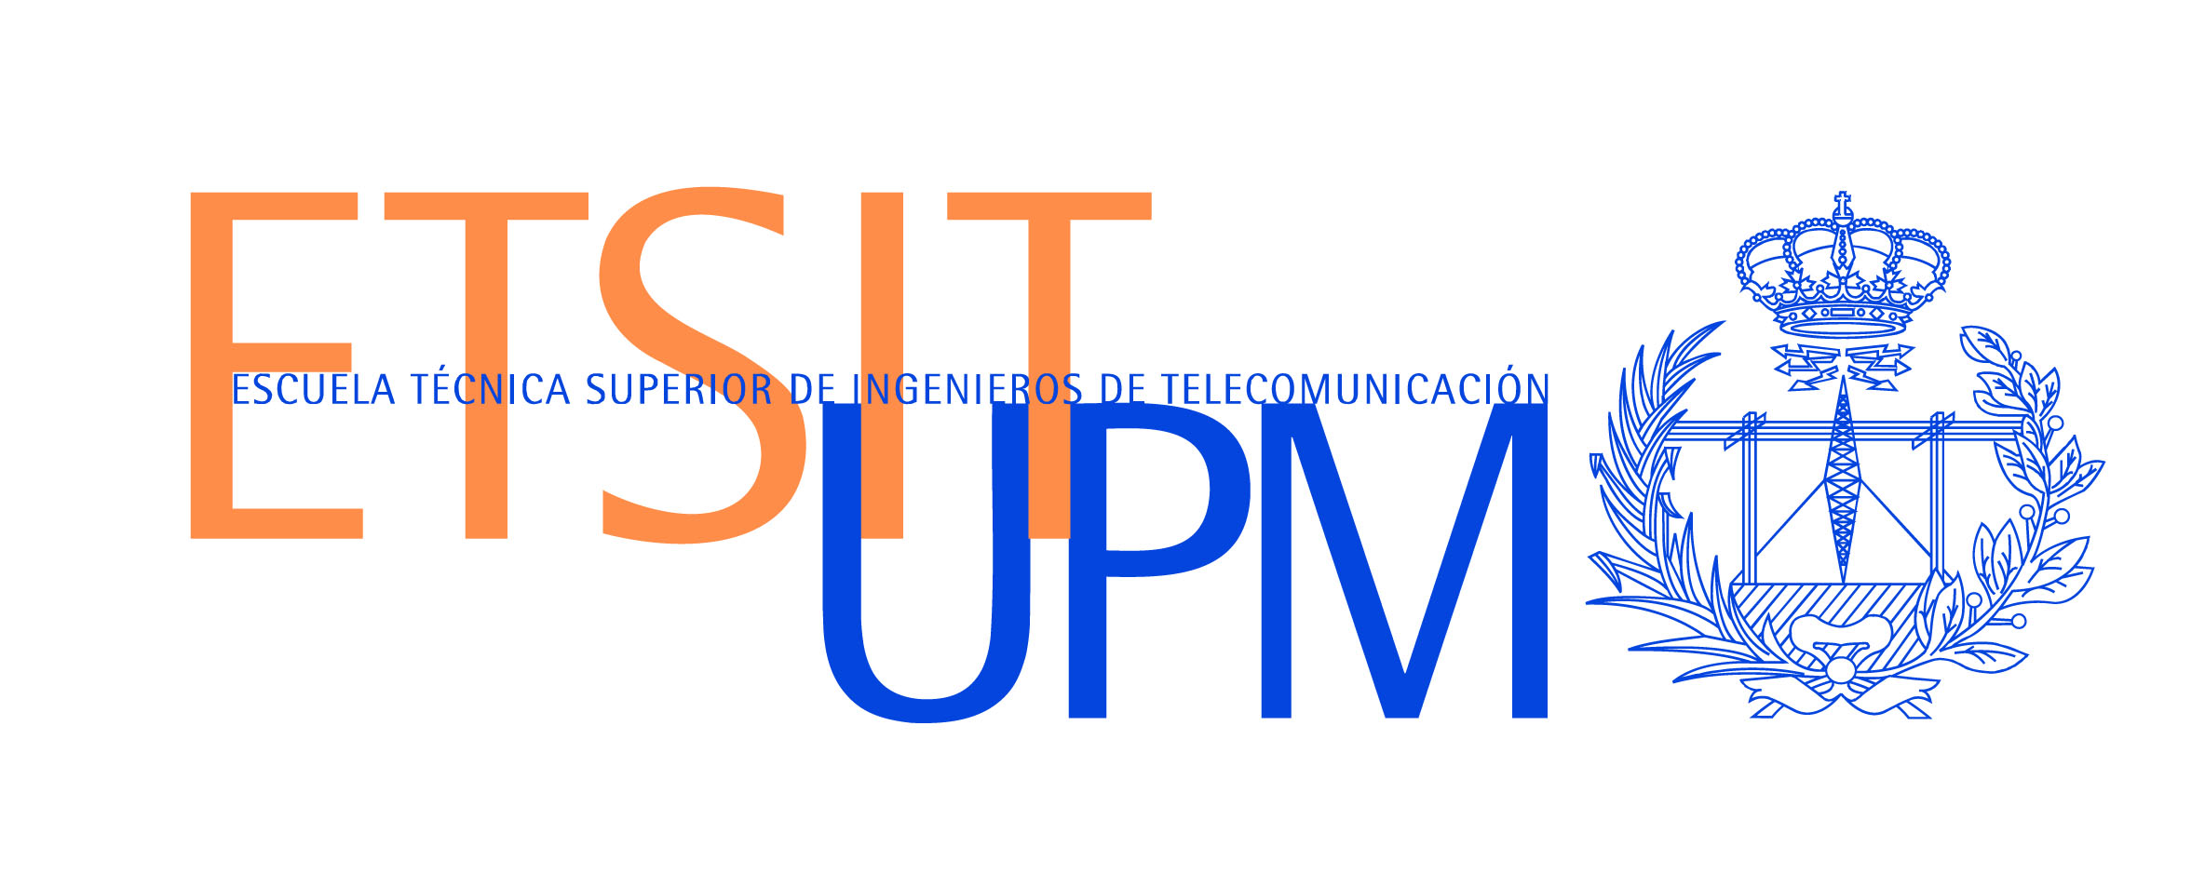

CONNECTED TV: GATEWAY TO THE JOB MARKET FOR THE DISABLED

- Researchers from the Technical University of Madrid's School of Telecommunications Engineering (ETSIT) have designed a connected television platform

- The platform, developed within the framework of the Indra-Adecco Foundation Chair of Accessible Technologies, will serve as a meeting place and broadcasting point for the disabled and employers

The potential of latest-generation television sets that can be connected to the Internet is opening up enormous possibilities in the provision of new user services. ETSIT researchers have seen how this potential can facilitate the social integration of the disabled. This has led to the creation of the INLADIS (Multi-screen Platform for the Integration of the Disabled into the Workforce) project, which is a platform with services to help this group's integration into the working world that has been developed within the framework of the Indra-Adecco Foundation Chair for research into Accessible Technologies of the Technical University of Madrid (UPM).

The HbbTV standard is an international initiative that has created an open specification for HBB (Hybrid Broadcast Broadband) systems, also known as hybrid television or connected television. It is characterised by the existence of hybrid screens that are capable of receiving and showing content from the traditional broadcast network (TDT) and the broadband network (Internet). The television set, equipped with a connector for Ethernet or Wi-Fi, is transformed into another element of the domestic network that is capable of accessing audiovisual content on the Internet.

Thanks to this standard, researchers of the Visual Telecommunications Application Group (G@TV), through the Indra-Adecco Foundation Chair, are developing a television platform in which people with various disabilities can access services such as distance learning and job offers. It will also enable employers and the public to obtain information about disability and the integration of the disabled into the workforce.

The users of this new platform will define the way they will interact with the interface upon registration and specify the type of technical help they need. For example, a blind person will receive the information from the platform in the form of voice messages by means of an audio file transmitted via the Internet. In the case of people with partial blindness, the platform enables the use of plain fonts and the adjustment of font sizes and the contrast between the colour of the text and the colour of the background.

The deaf and hearing impaired can benefit from videos with sign language and subtitles, as both types of information are included in the standard. People with reduced mobility or intellectual disabilities will benefit from a graphic interface that places special emphasis on visual aspects and intuitive navigation, facilitating menu and screen operations.

One of the main functions of the platform is access to job offers, which are incorporated in real time as soon as they are published by the personnel of the Adecco Foundation. The content of the offers is automatically reproduced with voice synthesis software to make it accessible for the visually impaired.

This project aims to contribute to the integration of the disabled into the workforce, given that this group is particularly vulnerable in situations like the current financial crisis and associated deterioration of the job market.

According to José Manuel Menéndez, the director of the Indra-Adecco Foundation Chair and of the G@TV, this platform "is only a sample of the great potential of Connected TV to provide users with innovative content thanks to the customisation capabilities provided by connection to the Internet". For Professor Menéndez, "the added value of the project lies in the fact that it also represents a social use for this technology". The G@TV has been a pioneer on the national level in research into new services and applications in relation to the HbbTV standard since 2010. The use of a standard specification like HbbTV enables interoperability between interactive content, TV operators and screens, which could not be achieved solely with the proprietary specifications of specific screen manufacturers.

The development of the HbbTV initiative was instigated in 2009 by a number of electronic and audiovisual industry (Philips, Samsung, Sony, LG, Loewe, Sharp, among others) and Internet companies, in addition to standardisation (European Broadcasting Union) and broadcasting (RTVE, France Télévisions, TF1, Canal +, NRJ 12, RTL Group, Astra, Eutelsat, Abertis Telecom, TDF, ITV, BSkyB) bodies, with the aim of unifying the various technological criteria to harmonise the convergence between television and the Internet in an open standard.

About the Indra-Adecco Foundation UPM Chair

The Indra-Adecco Foundation Chair of Accessible Technologies at the Technical University of Madrid was created in 2008 with the twofold objective of favouring the integration of the disabled into the workforce and contributing to the accessibility of audiovisual media. The Chair has mainly focussed on the dissemination of technologies for accessibility and the implementation of R&D projects to contribute to the achievement of these objectives, using the latest technological innovations available in the audiovisual world, such as interactivity and Connected TV.

About Indra

Indra is the leading technology multinational in Spain and a leader in Europe and Latin America. It is the second European company in its sector in terms of R&D, with €550 million invested in the last three years. Its turnover in 2011 was €2.688 billion, and currently 55% its income is from international markets. The company employs 42,000 professionals and has customers in 118 countries.

About the Adecco Foundation

Established in July 1999, the Adecco Foundation is the result of the social responsibility that Adecco has assumed as the world leader in human resource management. Its main objective is the inclusion in the job market of people who, due to their personal characteristics, find it harder to gain employment.
The Adecco Foundation carries out employment integration programmes for:
- Long-term unemployed men and women over 45
- Disabled people
- Women with sole responsibility for their families and/or victims of gender violence
- High performance sportspeople and ex-sportspeople

