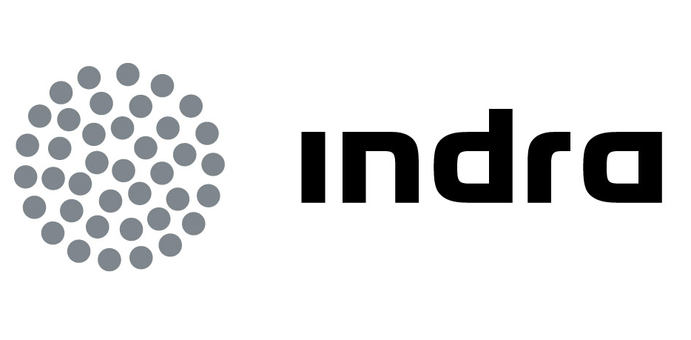 | Press  Release

INDRA TO COMMISSION
THE NEW KOLKATA AIR TRAFFIC CONTROL CENTRE
- Indra will also implement four simulators to train controllers in Delhi, Mumbai, Chennai and Kolkata
- These new contracts are in addition to those awarded to Indra in 2010 to deploy 9 radar stations and equip 38 airports with its systems

Indra will commission Kolkata's new control centre, which will be one of the largest in India, and will provide the Airports Authority of India (AAI) with simulation systems to train its controllers. Indra is the leader in the supply of Air Traffic Management systems, with more than 30 years' experience and projects in more than 95 countries.

These new contracts reinforce the company's solid position in the country. Indra's achievements in India so far include a major project in 2010 to deploy 9 Mode S radar stations and implement its air traffic management systems in the towers of 38 airports. At the time, this project constituted one of the largest contracts ever awarded in terms of the number of systems anywhere in the world.

The AAI has once again trusted in Indra's experience and know-how for its new control centre at Kolkata, which will operate with the company's automated air traffic management systems. This centre will be one of the four biggest in the country and, due to its location, will control a significant proportion of flights to and from Southeast Asia. Indra will equip the Kolkata centre with approximately 80 air traffic control positions.

Additionally, the company will provide the AAI with four approach and tower simulators, which will be operational at the country's main centres: Delhi, Mumbai, Chennai and Kolkata. Each one of them will have approximately 40 positions.

In addition to improving the training of its controllers, the simulators will enable the AAI to have a platform to carry out analyses and obtain statistics on the type of traffic using its airspace. It will also be able to simulate complex air traffic management scenarios and train its personnel to handle unusual situations and emergencies.

The Most Advanced Technology

Indra is the leader in technological innovation in ATM. In 2008 it completed the development and implementation of the first European trajectory-based flight management system, which was fully commissioned in the same year at the Maastricht Upper Area Control Centre operated by Eurocontrol. In 2011, it once again left its competitors behind by implementing and commissioning the first 4D (3D + Time) trajectory-based flight management system, which is operational at the DFS control centre in Karlsruhe.

Indra is one of the companies most involved in the Sesar R&D project, the technological pillar of the Single European Sky initiative. It is also working on the development of the iTEC, the future air traffic management system that will be shared by the Spanish (AENA), German (DFS), British (NATS) and Dutch (LVNL) air navigation service providers.

Indra in India

Indra has implemented its ticket systems in Mumbai's monorail and metro networks, Delhi's light metro link to the airport and Kolkata metro. It has also supplied the Indian Ministry of Defence with systems.

Indra is the leading technology multinational in Spain and a leader in Europe and Latin America. It is the second European company in its sector in terms of R&D, with €550 million invested in the last three years. Its turnover in 2011 was €2.688 billion, and more than half of its income is currently from international markets. The company employs 40,000 professionals and has customers in 118 countries.

