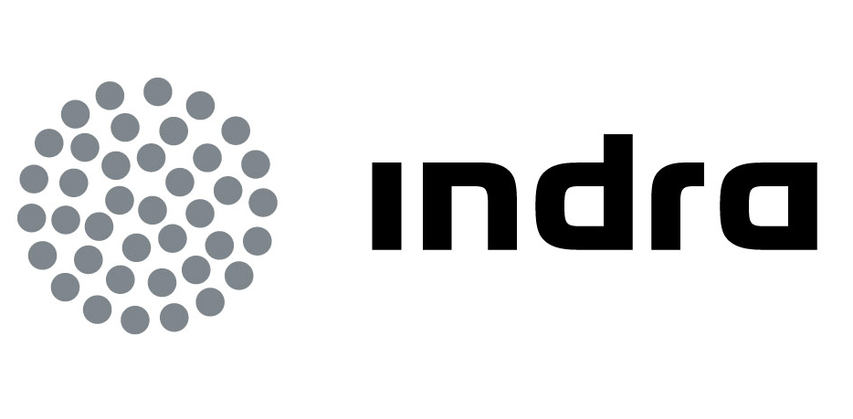 | Press  Release

INDRA WILL DEVELOP A SYSTEM TO HELP MANAGE NATURAL ASSETS AND QUANTIFY THEIR VALUE

- Estrateco makes it possible to forecast and simulate the impact of decisions made by authorities and businesses on the surrounding environmental assets, as well as to economically assess the corresponding impact

- The project has been selected to form part of Enterprise 2020, the only Corporate Social Responsibility leadership initiative recognised by the EU, because it applies innovation and technology to sustainable development

Indra, the leading Spanish multinational consulting and technology firm and one of the main players in Europe and Latin America, has completed the development of a system to manage natural assets and their economic value. The aim of this system is to help institutions and businesses make strategic decisions by offering a global vision of the impact of their decisions and operations on the total value of their ecosystem.

The result of an R&D&i project, Estrateco has been developed in cooperation with Argentina as part of the Iberoeka programme--a cooperation initiative between technological and innovative businesses in the Ibero-American region--and it has been backed by the CDTI in Spain. Aside from Indra, which has coordinated the work through its network of Software Labs, Ambiental Argentina SRL, an environmental consulting firm from the South American country, and the Spanish company Secuoyas, which is specialised in creating interactive multi-platform spaces and global strategies for the Internet, have also participated in the project.

Estrateco is aimed at authorities and businesses that manage environmental assets or whose operations affect the ecosystem. It enables simulating the impact of their decisions on natural assets in a simple, visual and user-friendly manner, as well as quantifying their economic value.

In the first step, Estrateco identifies the natural resources in an area based on orthophotographs and other satellite images, the results of forest extractions, fauna censuses, etc., as well as prior analyses and studies that have been carried out for the region. The economic assessment of the assets is then performed, and by applying a causal model based on artificial intelligence, the equivalence rules and relations between the various natural resources and their economic impact are established.

Using a dashboard based on actual data and management indicators, Estrateco displays in a simple manner the status of a region in terms of environmental aspects such as contamination, CO2 emissions, noises, water levels, erosion, the microclimate, biodiversity, etc., as well as urban indicators related to industrialisation, parks or leisure areas, residential areas, infrastructure projects, etc. Assets may also be considered in different dimensions, ranging from their physical descriptive data to the social/cultural opportunities they offer or their environmental/economic assessment.

"Serious game" philosophy for a greater impact

Because the "serious game" philosophy has been applied to the user interface design, the Estrateco system creates a simple interactive experience with a strong impact that promotes interest in the environment and helps increase awareness about its value. For example, aside from helping to manage natural assets, it also allows authorities to make the simulation tool available to citizens so they can see the consequences of their activities on their surroundings, propose improvements, use the tool for environmental education, etc.

Among other applications, the technology that has been developed makes it possible to view on a map of the region how building a business park or a road involves cutting down a certain number of trees and affects the fauna, and it also calculates the economic cost in the short and long term. Another example is the ability to predict the consequences of building a new development on a river's water flow or the region's energy needs, or the benefits of creating a green area in an industrial setting in terms of improving CO2 indexes, or to understand the economic consequences of these actions.

Pilot project in two Argentinian ecosystems

Estrateco has already been tested in the Argentinian ecosystems of Las Yungas and Valles Calchaquíes, located in the province of Tucumán and representing some of the most biodiverse areas in Argentina. Upon identifying the natural assets of both protected areas and quantifying their economic value, the tool allows measuring the possible benefits and costs involved in various actions, as well as different uses for the region, environmental improvements, damage to areas or assets, etc. Thanks to these simulations, Estrateco helps manage Las Yungas y Valles Calchaquíes, while making it possible to plan their progress.

Aside from carrying out this pilot, the solution has been presented to technicians and leaders of the public and private sectors in Buenos Aires, in the provinces of Neuquén, Tucumán, Salta, Mendoza and Jujuy, where the solution has received very positive feedback.

Innovation and technology for sustainable development

Estrateco has been selected to form part of Enterprise 2020, the only Corporate Social Responsibility (CSR) leadership initiative recognised by the European Commission. Participating in this initiative is recognition of Indra's effort in applying innovation and technology to address the sustainability challenges--in this case environmental--faced by society. It also recognises the open innovation model in which Indra works closely with its stakeholders to develop innovative solutions that contribute towards development that benefits its customers as well as society as a whole.

The Estrateco project has been conceived in accordance with the United Nations report titled "The Economics of Ecosystems and Biodiversity (TEEB)", which has resulted in a movement that aims to incorporate the value of ecosystems in the GDP calculation of each country, as well as by the new European guideline for Environmental Responsibility, which states that operators and businesses that damage the flora, fauna and water are directly responsible.

Indra is the leading consultancy technology multinational in Spain and a leader in Europe and Latin America. Innovation is the cornerstone of its business and sustainability, having allocated €550 million to R&D&i in the last three years, making it one of the leading companies in Europe in its sector in terms of investment. With sales approaching €3,000 million, nearly 60% of its income is from the international market. The company employs 42,000 professionals and has customers in 128 countries.

