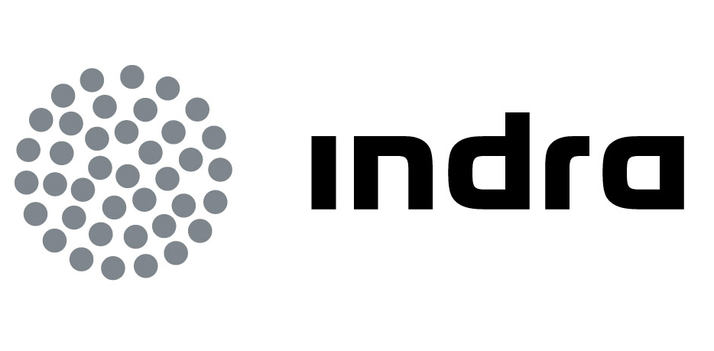 | Press release

INDRA DESIGNS THE STRATEGIC PLAN TO IMPLEMENT
SMART GRIDS IN PERU

- It has been selected by the Supervisory Body of Investments in Energy and Mines (OSINERGMIN) to carry out International Consultancy that covers diagnosing and implementing Smart Grids in the country

- Indra's analysis has assessed the main areas of application for smart grids, including the integration of distributed generation, demand management, distribution automation, smart meters and electric vehicles

- Implementing Smart Grids in the electrical system results in higher energy efficiency, more sustainable power generation and improved distribution quality, among other benefits

Indra, one of the leading IT multinationals in Europe and Latin America, has designed the strategic plan for the Peruvian administration to implement smart grids in the country's electrical system. The company has been awarded a contract with the Supervisory Body of Investments in Energy and Mines (OSINERGMIN).

OSINERGMIN is the public Peruvian body that is responsible for regulating and supervising companies in the electrical, hydrocarbon and mining sector to ensure they comply with the industry's regulatory framework. The institution's regulation and supervision efforts are guided by technical-financial criteria and contribute to the sustainable development of the nation's mining-energy sector.

The study completed by Indra allows to understand the overall conditions of the Peruvian electrical sector in terms of the market, technology and regulations. To prepare the study, the Peruvian market's current conditions have been taken into consideration along with forecasts, and multiple meetings have been arranged with various agents of the nation's electrical sector.

In addition, the main lines of action for implementing Smart Grids have been identified, along with smart meter equipment, the integration of distributed generation, demand management, distribution automation and electric vehicles. The characteristics of each of these lines of action have been studied in depth along with their impact on the system in terms of energy efficiency, asset management and improving service quality.

The document concludes with a proposed plan of action that includes the system's progressive development towards a new Smart Grids model and qualitatively describes the desired penetration levels for the corresponding technologies. The proposed strategy includes all the agents in the plan of action's development, based on identifying pilot projects that allow testing functionalities and technologies prior to the final regulatory development for a large-scale roll-out.

Main benefits

Opening Peru to Smart Grids will provide benefits to the current electrical system and the various agents that participate in it. On a global level, implementing these technologies will make it possible to improve the system's reliability and ensure the integration of new renewable energy (600 MW planned in Peru during the next two years).

The implementation of distributed generation and demand management will make it possible to reduce power peaks and the requirements of new investments in generation and grids, which is very relevant in a country with an annual consumption growth rate of more than 7%.

Finally, consumers will receive services of improved quality with a grid that has a higher level of monitoring and automation, allowing them to manage their energy consumption more efficiently.

Sustainability and energy efficiency

Indra currently works towards developing new technologies and solutions in the area of energy efficiency and sustainability for generation, transmission, distribution, transport, industrial and residential consumption. The company is currently working on various Smart Grid projects that ensure sustainable, safe and economic development, and it is also participating as an advisor in the National Energy Commission (Spain) to develop Smart Grids within the Smart Grids work group.

Together with Gas Natural Fenosa, Indra is leading Energos R&D&i project with a €24 million budget, 50% of public funds from CDTI, and the objective of developing methods and technologies for future grids. It has also participated with the power company in the European Union's 3E Houses project with the objective of showing and quantifying the contribution of IT towards improving energy efficiency in homes through a pilot study involving subsidised housing located in Sant Cugat del Vallés.

In addition, it works on other R&D&i projects together with REE, Gas Natural Fenosa, Endesa and Iberdrola to develop new systems (grid models, real time integration platforms and two-way communication solutions), and it has completed the development of a new generation of smart meters. The technological company is also actively involved in work groups fostered by Spain's Ministry of Industry to promote the development of electric vehicles in Spain, in addition to collaborating in various research projects and initiatives with different agents and companies within the energy sector.

Indra is the number one technology multinational in Spain and one of the leaders in Europe and Latin America. It is the second European company in its sector in terms of R&D, with €550 million invested in the last three years. Its turnover in 2011 was €2,688m and today more than half of its income is from international markets. The company employs 40,000 professionals and has customers in 118 countries.

